\2

SCHOOL OF INFORMATICS & IT

Storytelling Dashboard – Part 2

Student Name (Matric Number) : 2302276G

Tutorial Group : PC02
Jenny LING (TP)
Tutor : Ophelia Lim

Submission Date : 9/12/2024

Declaration of Originality

I am the originator of this work and I have appropriately acknowledged all other original sources used as my references for this work.

I understand that Plagiarism is the act of taking and using the whole or any part of another person’s work, including work generated by AI, and presenting it as my own.

I understand that Plagiarism is an academic offence
and if I am found to have committed or abetted the offence of plagiarism in relation to this submitted work, disciplinary action will be enforced.

Task 1 : Visual Cues

[ Show and explain at least TWO enhancements to your visuals ]
[ Include relevant screenshots ]
[ Refer to the assignment specification for more details ]

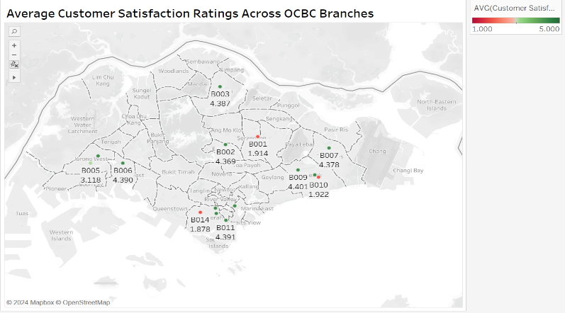
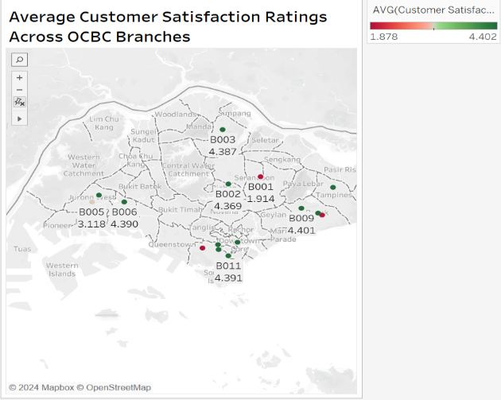
Before After

I standardized the colour filter range across all the graphs to ensure consistency in the visual representation of customer satisfaction. Regardless of whether they are looking at the map or the bar chart, customers can interpret colours consistently throughout all the charts by using the same range which is 1 to 5. For instance, regardless of the graph, green always represents high satisfaction and red indicates low satisfaction. This improvement makes use of colour and contrast to ensure that users can quickly distinguish between high- and low-performing metrics. The standardization helps to enhance the user experience and its easier now to compare the results between each graph. A visual hierarchy is automatically created by this consistent colour palette, which helps users prioritise important insights and highlights problem areas like low satisfaction ratings. Additionally, by removing the need to interpret different colour schemes across graphs, the constant usage of colours de-clutters the visuals and lessens confusion. Additionally, it guarantees that graph-to-graph interaction—like applying filters or clicking on data points—feels natural and reasonable. By establishing a standardized colour filter range, users can quickly spot patterns and trends in graphs without needing to learn or alter their interpretation, which ultimately saves time and increases the precision of their decisions.

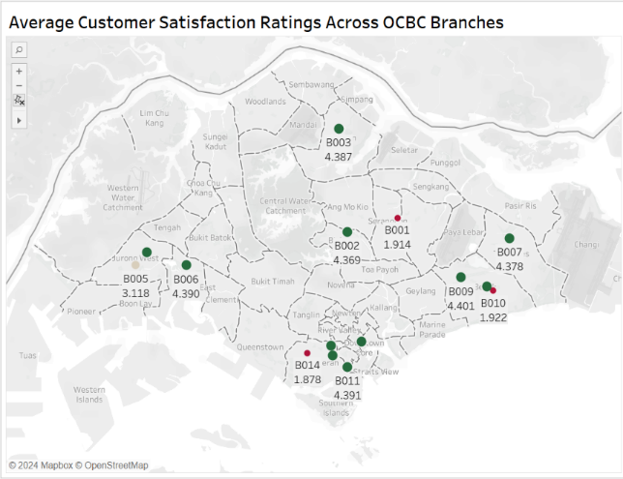
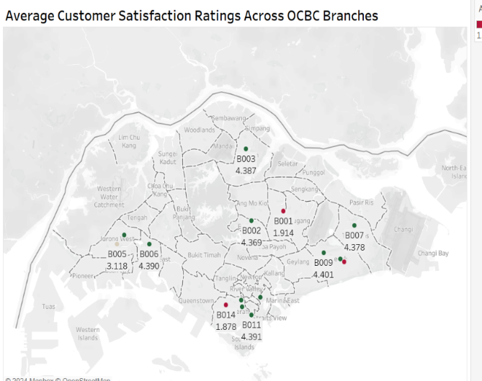
Before After

The initial map visualization had the same size markers for all the branches, which made it tough to identify key patterns. I then decided to adjust the marker sizes based on the satisfaction rating of the branch, where the marker size increases as the satisfaction score increases. This creates a visual hierarchy, allowing users to identify the high and low performing branches briefly. By adding variation in marker sizes, it also de-clutters the map by lowering the visual monotony brought on by identical markers and improving readability of the map. Furthermore, this guarantees that the map better fulfils its objective of visualising spatial data, which is consistent with the idea of using suitable visuals. The map is now more visually appealing and usable, making it easier to derive insights from it. It helps enable decision-makers to identify low performing branches and take action to improve customer satisfaction.

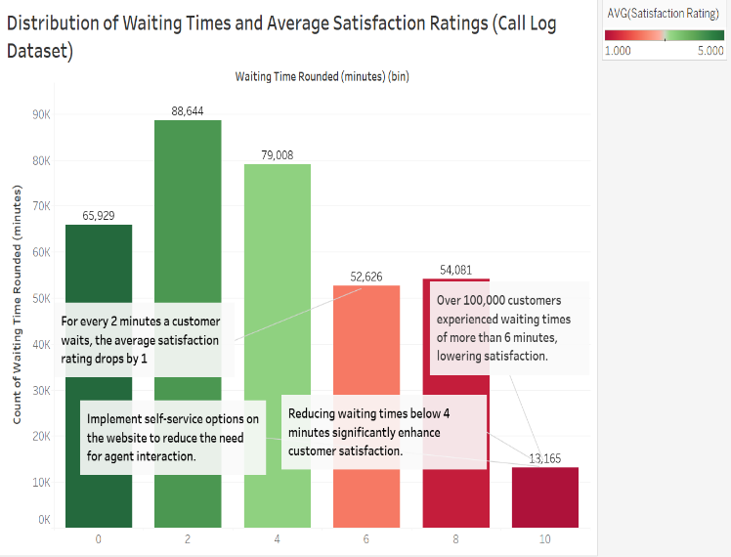
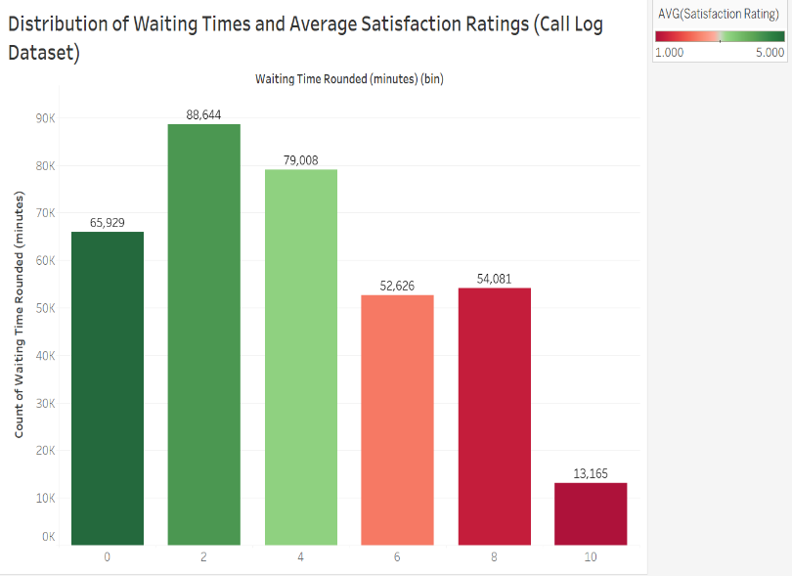
Before After

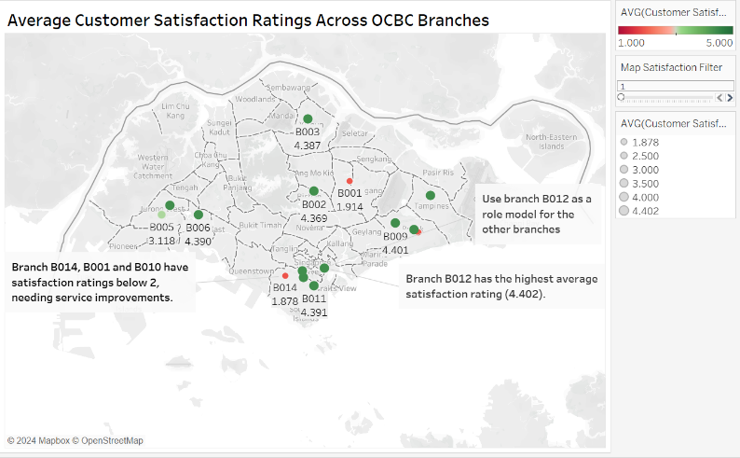
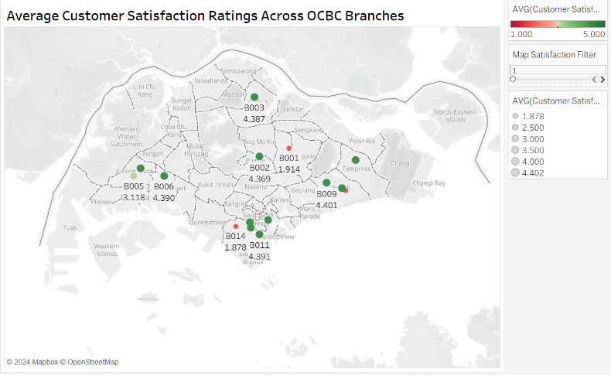
Before After

The initial graph lacked context which made it harder for users to understand key insights or patterns. Therefore, I added annotations to highlight the key insights from the graphs. The annotations include the highest value in the graph and solutions to the issues such as implementing self-service options. The annotations enhance the graph's overall usefulness and clarity by highlighting key components. By ensuring that viewers can quickly understand the key takeaways, this improvement makes the visualisations more significant, informative, and useful for decision-making. Users can make more informed decisions by adding annotations, which help them quickly understand important insights such as over 100,000 customers experienced waiting times of more than 6 minutes.

Task 2 : Dashboard

[ Show and explain ONE dashboard, including any interactivity used ]
[ Include relevant screenshots ]
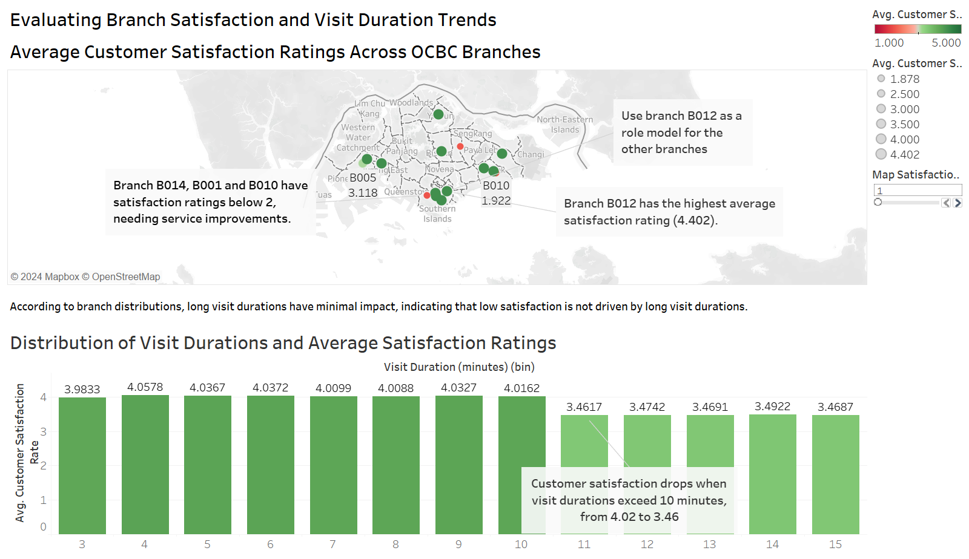
[ Refer to the assignment specification for more details ]
The dashboard's map and bar chart, which are both taken from the walk-in dataset, are intended to achieve a balance between providing a broad overview and in-depth insights. To give a high-level geographic view on average customer satisfaction ratings across OCBC branches, the map is positioned at the top. To ensure clarity and prompt identification of branch performance, markers of various sizes and colours are used as visual cues. Larger, greener markers indicate better satisfaction ratings. The map is enhanced by the bar chart at the bottom, which provides a thorough analysis of typical visit durations and customer satisfaction. To improve visual hierarchy and concentration, annotations are added to emphasise important data points, such as the highest performing branch.

The dashboard efficiently conveys information by reducing complicated datasets to two separate but complimentary visualisations. While the bar graph offers complete details about visit durations and how they affect customer satisfaction, the map gives users a macro-level picture of branch performance. The dashboard removes confusion by making sure every visual has a purpose and is properly labelled.

The insights that can be derived from the charts are very useful for decision-making. The map helps identify the best and worst performing branches, allowing the company to act and improve the low performing ones. Similarly, the bar chart shows the distribution of visit durations and what was the satisfaction rating given for the service. This will allow OCBC to identify operational inefficiencies. With the help of these graphs, OCBC can set priorities for resources and create plans for improving customer satisfaction.

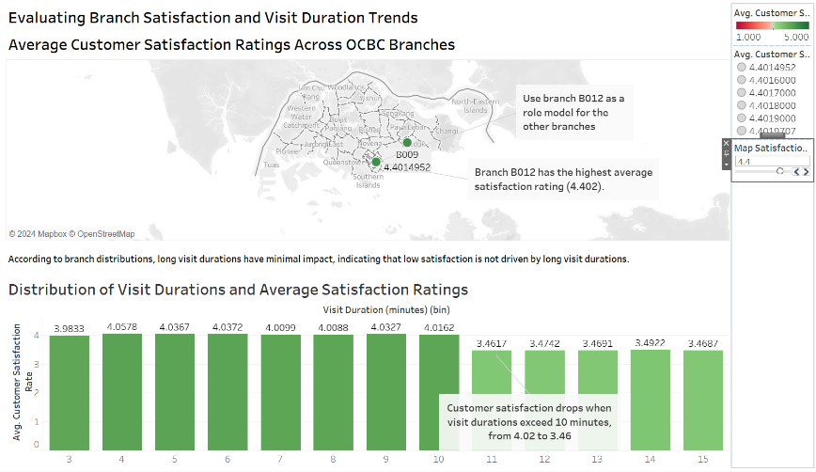
The dashboard is simple and intuitive, making it user friendly. The clear layout, readable fonts and consistent colours allows users to understand the data easily. The visuals are arranged to create a logical flow where the map provides the overview while the bar chart shows the small details. This makes the dashboard usable by many different users of different degrees of data literacy.
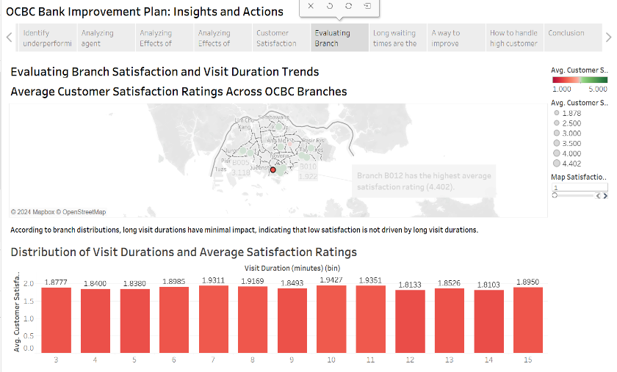

To enhance interactivity, I included parameters to the map to improve user engagement by enabling dynamic filtering of satisfaction ratings. Users can view branches with ratings over a specific threshold, for instance, by adjusting a slider. To allow visitors to see how a data point (such as a branch or the reason for a visit) changes the other chart, I included interactive filters. By allowing a more thorough examination of relationships and patterns, these features enhance usability and make the dashboard easier to use and more effective.

This dashboard enables OCBC to identify operational inefficiencies, efficiently allocate resources, and implement targeted measures to enhance customer satisfaction.

Task 4 : Big Idea, Linear Storyboard, Narrative Framework

[ Include a screenshot of your Big Idea using the template taught in eLearning ]
[ Include a screenshot of your linear storyboard ]
[ Include a screenshot of your narrative framework ]
[ Refer to the assignment specification for more details ]
Big Idea
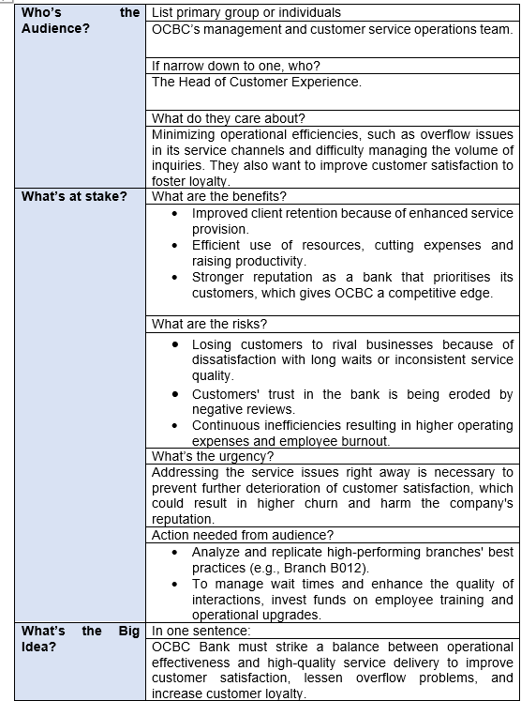

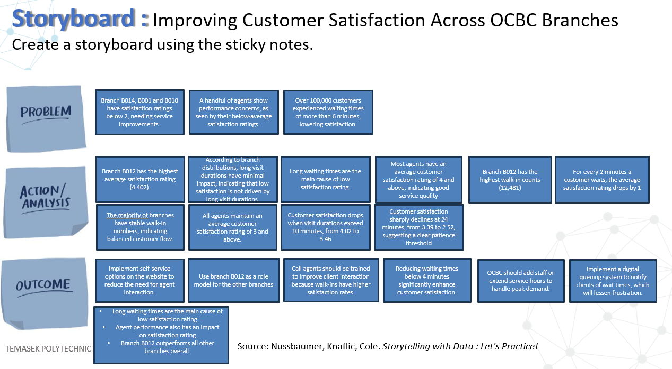
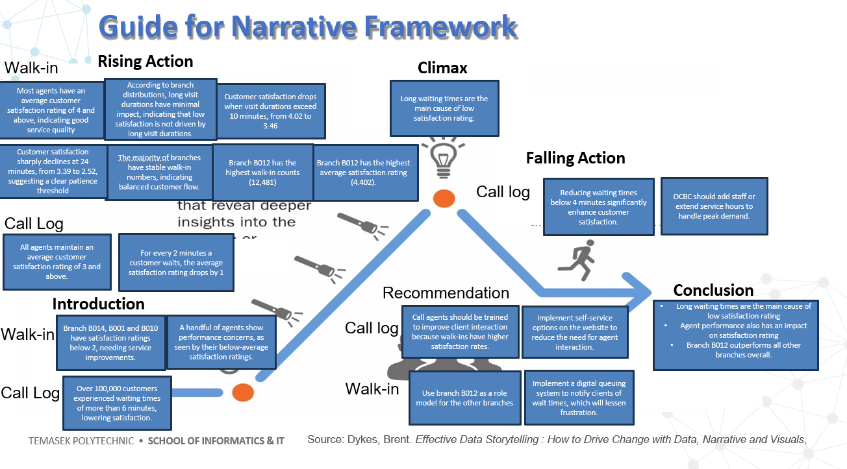
I separated the sticky notes into walk-in and call log for introduction, rising action, falling action and conclusion, which will make it easier for readers to follow and understand. This separation guarantees that the distinct difficulties and opportunities of each service category are effectively conveyed, assisting the audience in understanding their interconnections while concentrating on their distinct effects.

The introduction mentions that many customers experience long wait times and that several branches (B014, B001, and B010) have extremely low satisfaction ratings. By highlighting the importance for immediate attention of operational faults, this introduction creates initial tension.

More details are displayed by the rising action, including customer satisfaction threshold, agent performance insights, and high-performing branches like B012. These details stimulate curiosity and bring us closer to the turning point.

The climax provides a unifying insight of both call log and walk-in: "Long waiting times are the main cause of low satisfaction ratings." This highlights the need for action and highlights how important it is to shorten waiting times.

The falling action provides recommendations that could be immediately put into practice to address the problems mentioned in the climax. These recommendations include reducing waiting times to below 4 minutes and add staff or extend service hours during peak demand. These feasible solutions are intended to directly address the main issues noted, guaranteeing a prompt and efficient resolution.

The conclusion reinforces the significance of resolving the challenges raised by bringing the main conclusions and useful recommendations together. It places a strong emphasis on reducing wait times, improving agent performance, and implementing best practices from branches with excellent performance, such as B012. To reduce waiting time, improve customer satisfaction and streamline processes, recommendations such as implementing a digital queue system and introducing self-service options on the websites are made. The conclusion successfully answers the audience's main concerns by outlining the advantages of these steps, responding to the question, "What is in it for me?" and motivating them to implement the suggested fixes.

The audience is kept interested, tension is created, and practical insights are offered for solving important service issues with the use of the Freytag Pyramid.

Task 5 : Tableau Story

[ Show and explain your Tableau Story (with a maximum of 12 story points) ]
[ Include relevant screenshots of your Tableau Story ]
[ Refer to the assignment specification for more details ]

Introduction

OCBC Bank's main service problems are clearly outlined in the introduction, with specific focus paid to underperforming branches, long wait times, and gaps in agent performance. It makes use of powerful visuals to establish a captivating hook and inspire a sense of urgency to solve these problems and improve customer satisfaction.
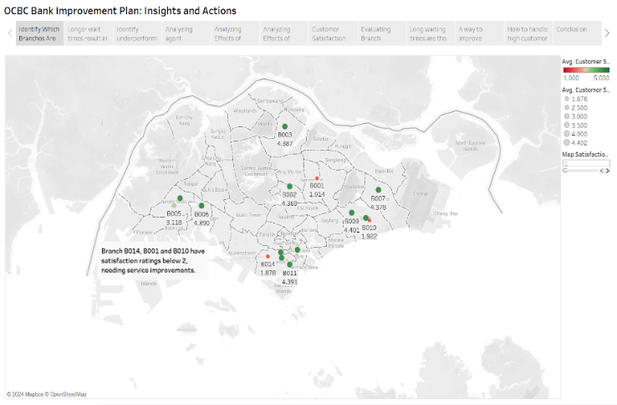
A clear picture of branch performance is given by the branch satisfaction map, which highlights underperforming branches with satisfaction ratings below 2, such as B014, B001, and B010. Smaller red markers are used to visually represent these branches, highlighting their lower satisfaction rating, and drawing attention to them right away.

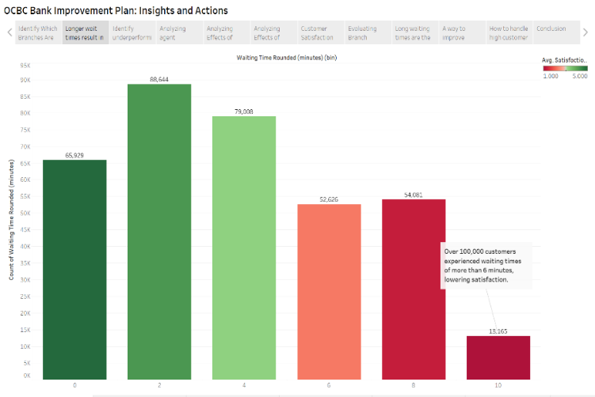

The waiting time bar chart highlights the problem even further by showing that over 100,000 customers experienced waiting times of more than 6 minutes, which significantly reduced their satisfaction rating.

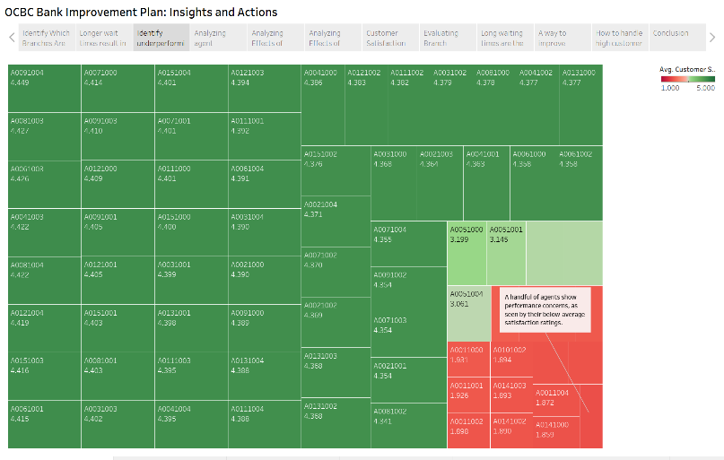

Lastly, the agent performance treemap offers a thorough analysis, identifying agents with ratings below average. By highlighting performance disparities in particular agents, this detailed knowledge enables targeted actions to solve these issues.

When combined, these visuals form an engaging narrative framework that successfully introduces the main service issues OCBC is facing. The introduction makes sure that the audience is interested and prepared for the more in-depth analysis and solutions that will be provided in the following sections by combining high-level and specific ideas.

Rising Action

The rising action charts emphasise in-depth analysis to draw attention to important service issues and places where OCBC's operations might use some improvement. These charts offer intermediate results, laying the groundwork for the main revelation in the climax.
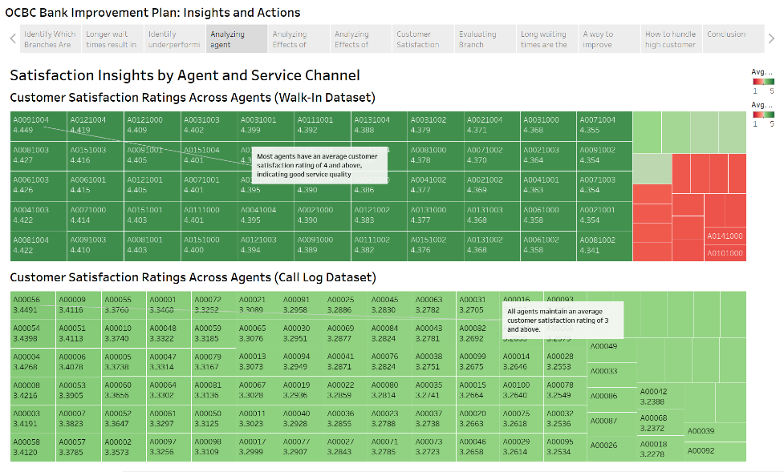
The agent performance treemaps create performance differences easier to understand by breaking them down by service channels (call log and walk-in). While some walk-in agents, as indicated in red, have satisfaction ratings that are unacceptable, the majority receive ratings above 4. Likewise, the average score for call log agents is often 3. Walk-in agents have a higher satisfaction rating as compared to call log agents, showing a gap in service-quality between the two channels.
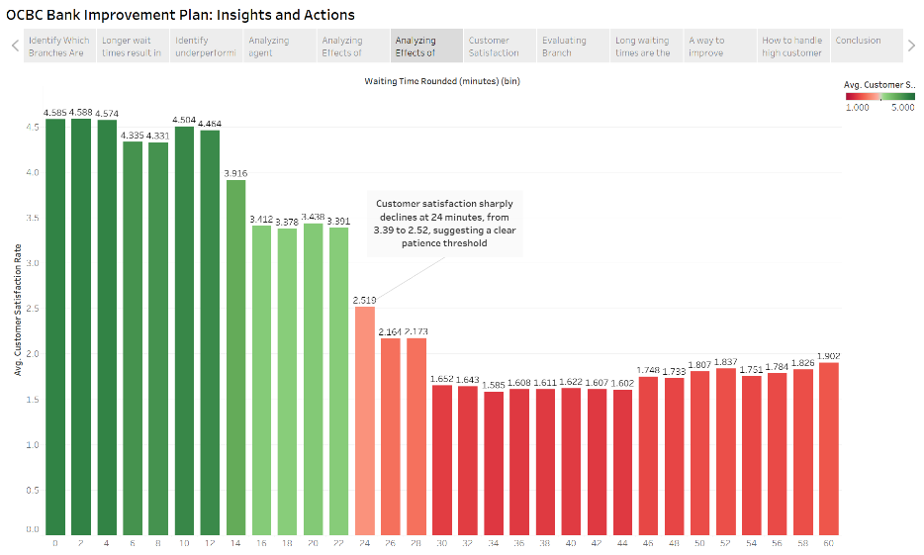
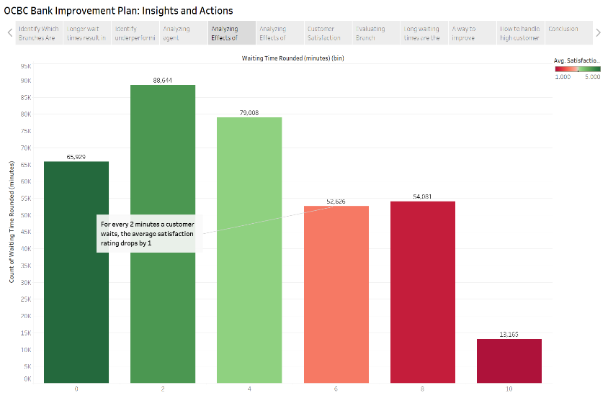
The need of addressing operational inefficiencies is further shown by the waiting time bar charts. Customer satisfaction drops by 1 for every 2 minutes a customer waits, as the call log waiting time bar chart illustrates. The following chart measures the changes in satisfaction for the walk-in waiting time bar chart. Customer satisfaction sharply declines at 24 minutes, from 3.39 to 2.52, suggesting a clear patience threshold. These observations highlight the importance of interventions for efficient waiting time management to improve customer satisfaction.

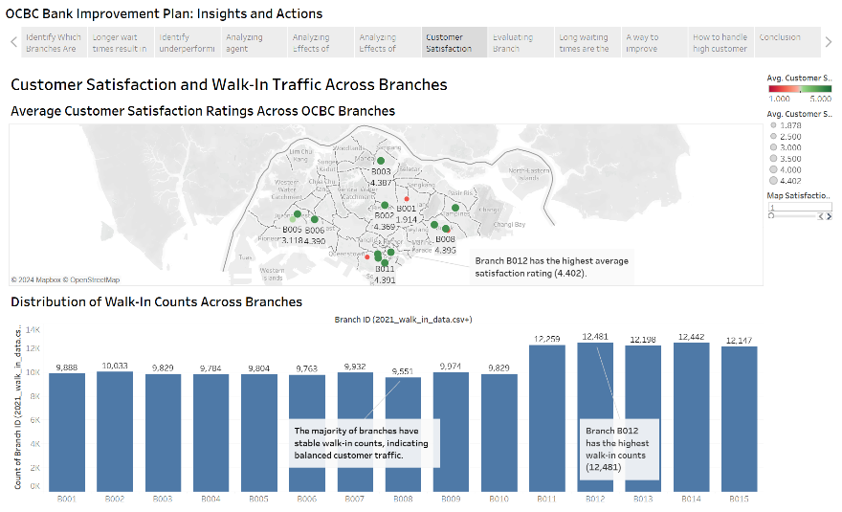
The Customer Satisfaction and Walk-In Traffic Across Branches dashboard provide further granularity. The walk-in branch satisfaction map identifies the highest performing branch which is B012 with a satisfaction rating of 4.402. The chart below shows the distribution of walk-in counts across branches and that branch B012 has the highest walk-in count with 12,481. Also, majority of branches have stable walk-in counts, indicating balanced customer traffic. This means that a high customer traffic does not have a very big impact on customer satisfaction as branch B012 has the highest walk-in count but also the highest satisfaction rating.
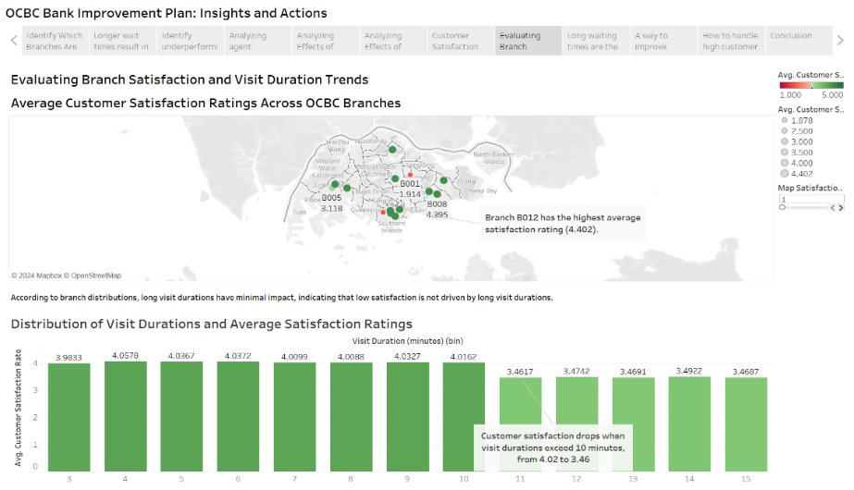
This dashboard highlights branch performance and the impact of visit durations on customer satisfaction. For the first chart, which is the walk-in branch satisfaction map, it has already been explained in the previous dashboard or data story point. For the second chart, it shows the distribution of visit durations and average satisfaction ratings. The chart shows that customer satisfaction drops when visit durations exceed 10 minutes, from 4.02 to 3.46. Although it may seem that a long visit duration has a big impact on customer satisfaction, it does not. For branch B014, no matter the visit duration, the average satisfaction rating is at most 2. This applies to other branches too where the satisfaction rating for long visit durations is about the same as the short ones. This means that long visit durations have minimal impact on customer satisfaction rating.

By building tension and preparing the viewer for practical answers at the climax, these rising action visualisations work in unison to show mounting evidence of service inefficiencies and support the narrative structure. By offering in-depth, visually appealing insights that link the introduction and the climax, they enhance the story and emphasise how urgent change is.

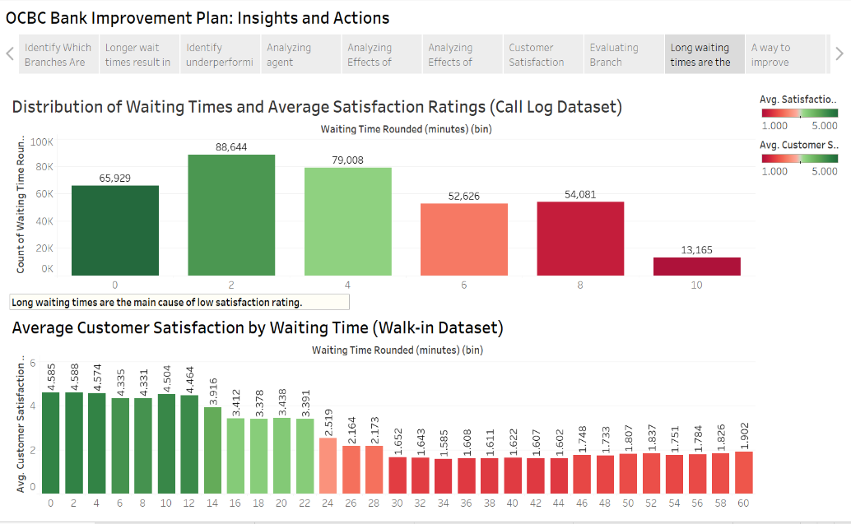
Climax

The climax unifies insights from both the walk-in and call log datasets to emphasize that long waiting times are the main cause of low customer satisfaction rating. In both the call log and walk-in charts, the customer satisfaction rating starts to lessen as the waiting time increases. These visuals create a sense of urgency, which not only fits with the story's structure but also acts as a powerful hook. To increase customer satisfaction, they urge decision-makers to give lesser waiting times a top priority by clearly communicating the issue and offering useful insights. Visual storytelling and data-driven insights work together to reinforce the overall message and immediately address the problem statement, urging quick action.

Falling Action

The falling action visualisations focus on realistic recommendations to handle the difficulties of high customer demand and long waiting times while making a smooth transition from the climax. With their emphasis on urgency and concise solutions, these charts offer useful insights and reinforce the narrative framework.
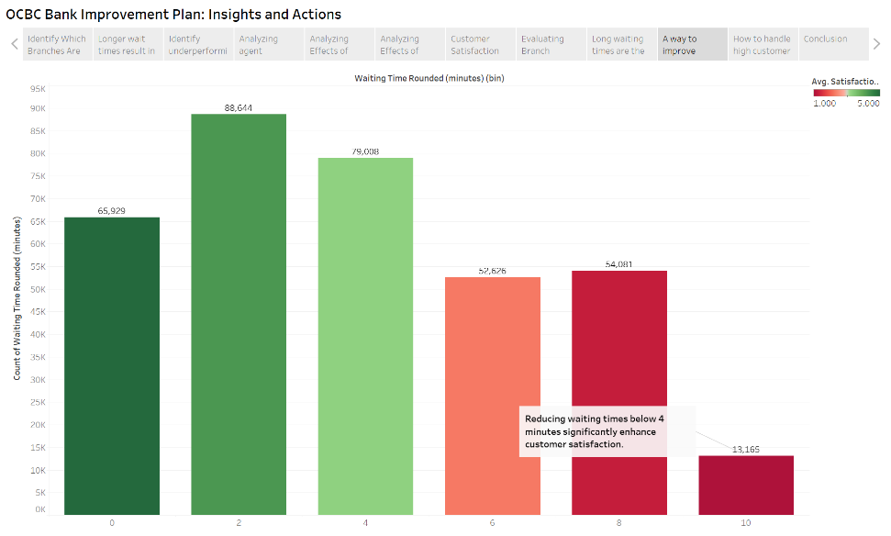

Reducing waiting times below 4 minutes significantly enhances customer satisfaction as shown by the first chart. The importance of operational adjustments to maximise service efficiency is strongly highlighted by this chart. This encourages quick action by directly addressing the issue of low satisfaction ratings brought on by the long waiting time.

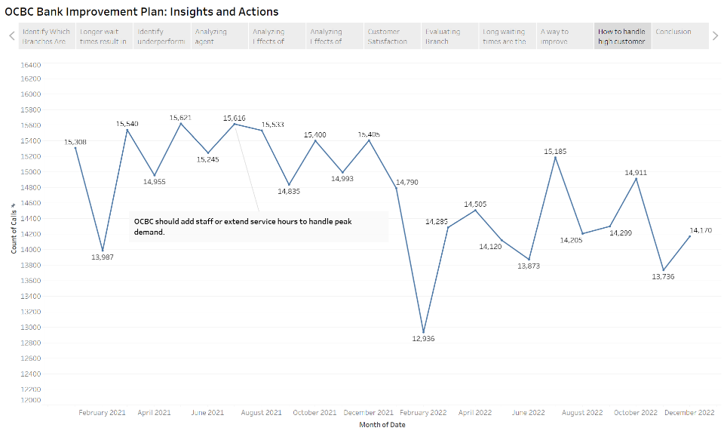
The second chart shows the monthly call volumes over a two-year period. It helps identify peaks and troughs which allows the company to adjust their resources based on the months. The annotation highlights that OCBC should add staff or extend service hours to handle peak demand. By giving decision-makers insight on workload patterns, this visualisation enhances the overall story and aids in setting priorities for resource allocation and workforce planning.

These charts give a clear call to action and instil a sense of urgency. By providing practical solutions to operational inefficiencies, they respond to the problem statement. The suggestions are easy to comprehend and put into practice thanks to the straightforward and understandable visuals. The conclusion follows naturally from this falling action, which successfully connects the insights to solutions.

Conclusion
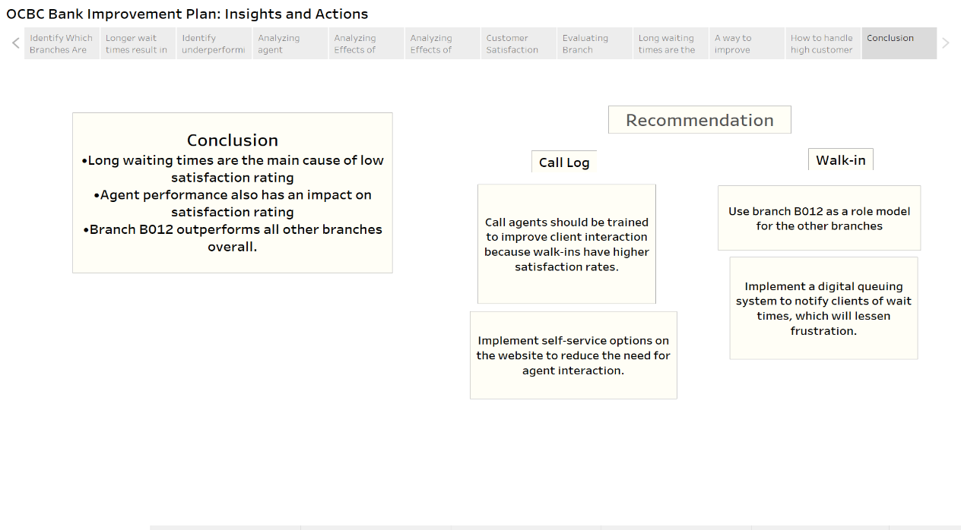

The analysis's findings are put together in the conclusion, which also offers practical recommendations for resolving the issues that were identified. By restating the main conclusions—such as the effects of long wait times, agent performance differences, and Branch B012's excellent performance—it successfully integrates the narrative framework.

By directly connecting the conclusion to the recommendations, the visual structure supports the message. Both call log and walk-in customer service issues are tackled by the recommendations. For call logs, training agents and adding self-service options can improve interactions. For walk-ins, using Branch B012 as a role model and implementing a digital queuing system are practical ways to reduce frustration and boost satisfaction.

This conclusion promotes trust in the solutions recommended and creates a sense of urgency by highlighting the necessity of resolving significant issues. It is a direct call to action that supports the main objective of raising operational effectiveness and customer satisfaction.

SUBMISSION INSTRUCTIONS

- Save this file as “SD2_[Your Class]_[Your Full Name]_[Your Student ID]”, e.g. “SD2_P01_BATMAN ROBIN_2399999A”.
- Submit your report in MS Word document to DAST LMS site > Assessment >
SD Part 2 Submission Link.

